**Basic Selenium Grid Configuration**

**Prerequisites**

* Java should be installed in your Machine.
* Project Configuration Should be done properly.

Please refer Doc for Projects Configuration - [Projects Configuration](https://prophoenix.sharepoint.com/:w:/r/sites/Engineering/Shared%20Documents/QA/Test%20Automation/Automation%20Projects%20and%20Detailed%20structure%20Documents/Projects%20Configuration%20Document.docx?d=w1ab1dc012c8b43ddb6cb9ee0a9669afa&csf=1&web=1&e=g8aO5K)

The ways we can run our Automation scripts:

* We can run by Local M/c – By giving Local m/c driver path.

* We can run scripts in remote M/c using selenium Grid.

To Configure selenium Grid, we need to Download Grid server from below link.

<https://www.selenium.dev/>

Click on Download after hitting URL, Click on Latest Stable version then it will download server.

1. To run Hub and Node in single command

java -jar selenium-server-4.3.0.jar standalone --max-sessions 2

note: Remember you need to keep Browser driver and Selenium grid server in same folder.

1. To run Hub and Node as separate command
2. **Hub**

java -jar selenium-server-4.3.0.jar hub

1. **Node**

java -jar selenium-server-4.3.0.jar node --port 1111 --max-sessions 1 --session-timeout 300000

note: You can run multiple nodes by changing Port no

1. **node 2**

java -jar selenium-server-4.3.0.jar node --port 1112 --max-sessions 1 --session-timeout 300000

note: maximum we can go for three nodes for one hub to achieve smooth run.

Since we made all these commands as batch file, we can deploy Grid Configuration folder on desktop of M/c’s we want to run scripts.

**Grid Configuration**

* **Copy Folder Grid Configuration from Below Path**

**\\10.103.3.178\Mahesh440Share\GridConfiguration** **à open as Hyperlink**

* To Start Hub go to Hub Folder And Edit HubStart.bat according to Your Machine Path and Double click.

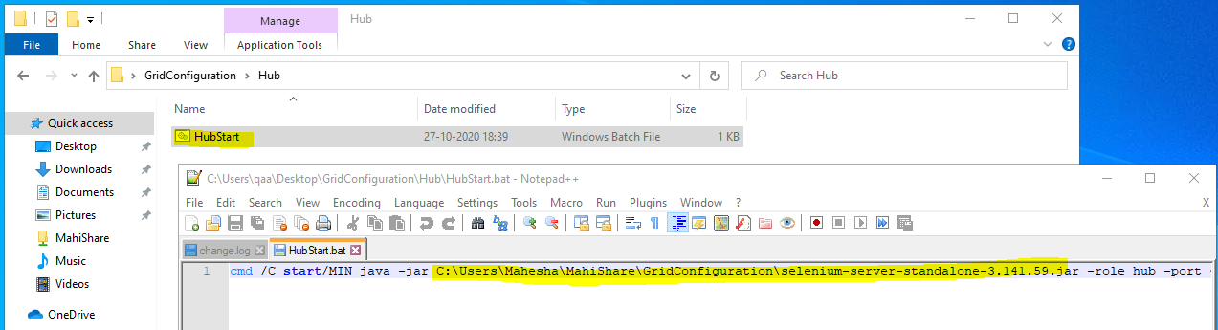

* To Start node go to nodes Folder And Edit node.bat according to Your Machine Path and Double click.

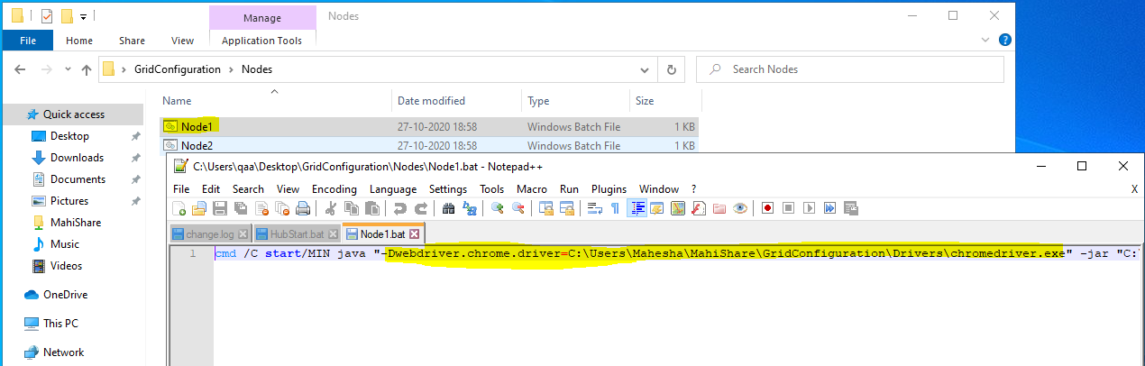

* If you want To Configure Multiple nodes, you can configure Node2 Node3 with different Port No.

To run Scripts on VM

Run Hub from local m/c

Connect nodes from VM

Thank You…